# Computer Networks Lab Assignment

**Assignment-4**

August 24,2018

**1. Find the last ARP packet in the file. What IP address was it asking about?**

The last ARP packet was numbered 924 the below screenshot.

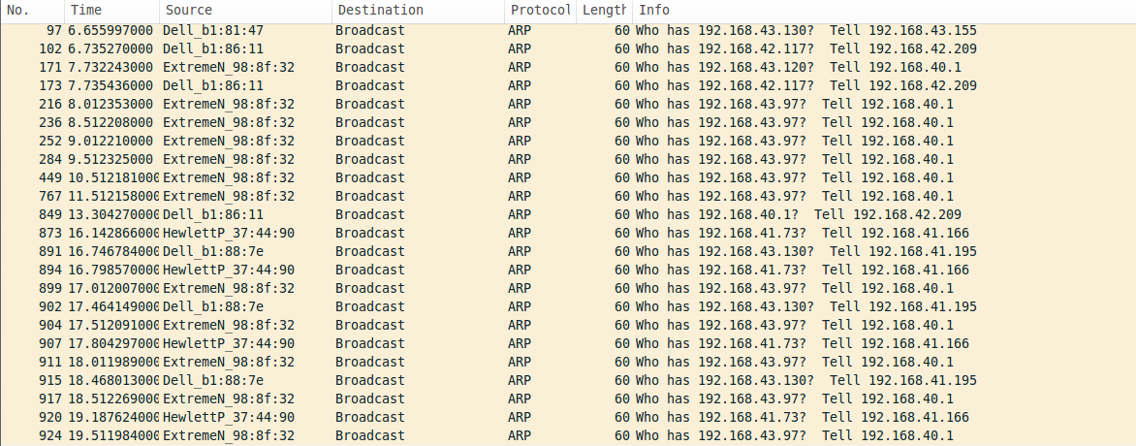

The Ip address it was asking is 192.168.43.97

**2. Find the first DNS request. What is its Transaction ID in hexadecimal?**

The first DNS request is numbered 41s shown in the screenshot below.

Transaction ID in hexadecimal is 0x71f6

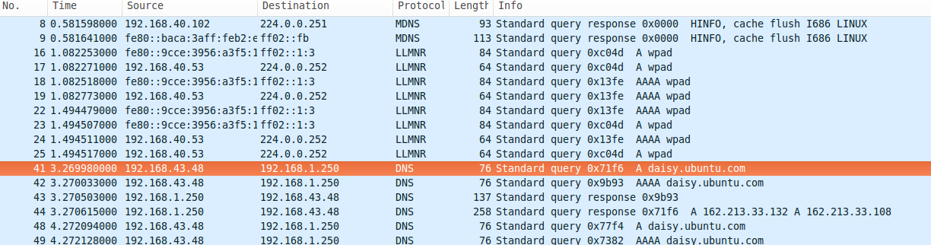

**3. What domain name was it requesting?**

The domain name it was requesting was [w](http://www.google.co.in/)ww.daisy.ubuntu.com

**4. What type of DNS resource record (RR) was requested?**

Resource Record of type A was requested. Record A specifies IP address (IPv4) for given host. A records are used for conversion of domain names to corresponding IP addresses.

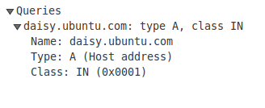

**5. Find the response to that DNS request. What was the first IP address that it returned?**

Response was the IP address of the requested domain name which was shown in packet number 44 of the screenshot.

The first IP address that it returned was 162.213.33.132.

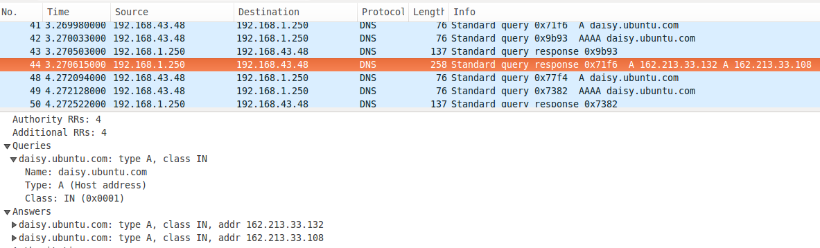

**6. Find the first IPv4 TCP packet. What is its source IP address?**

The first IPv4 TCP packet is numbered 57 as shown in the screenshot below.

Its source IP address is 192.168.43.48.

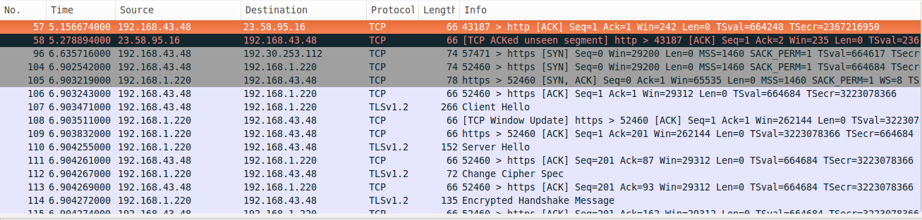

**7. Find the first TCP (IPv4 or IPv6) three-way handshake.**

The packet numbers 104,105,106 in the below screenshot indicate three-way handshake.

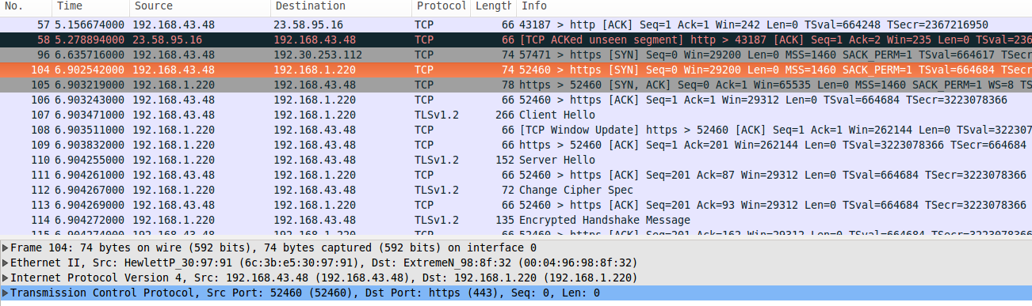

**8a. What is the source IP address in its opening SYN packet?**

The source IP address in the opening SYN packet is 192.168.43.48.

**8b. What is the destination IP address in its opening SYN packet?**

The destination IP address in the opening SYN packet is 14.139.1.220.

**9. What is the (absolute) Sequence number sent in response to question 8’s opening SYN packet?**

The sequence number sent is ‘0’.

**10. Find the last TCP packet in the file that has its FIN flag on.**

The last TCP packet with FIN flag on is numbered 817 in the below screenshot.

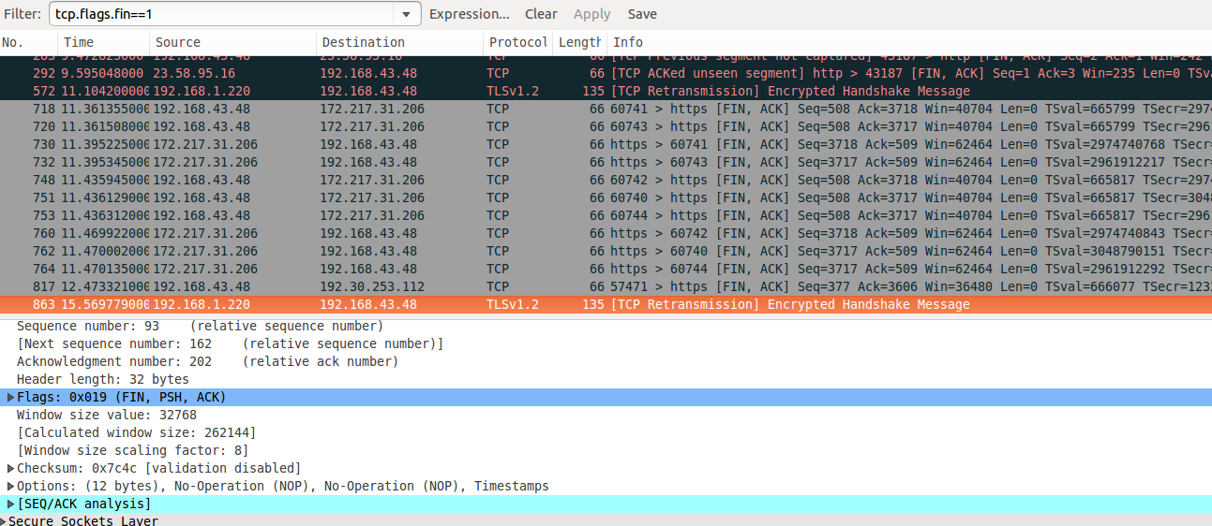

**10a. What is the source port number?**

Source port number is 57471.

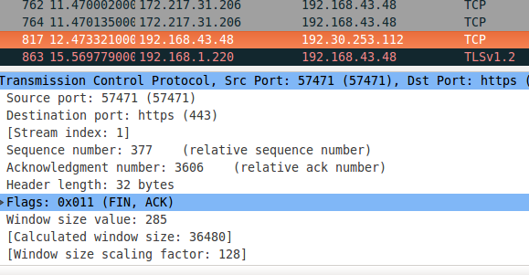

**10b. What is the destination port number?**

Destination port number is 443.



**11. Now find the opening SYN+ACK packet that began the TCP session ending with that FIN packet. What is its sequence number?**

Sequence number='0'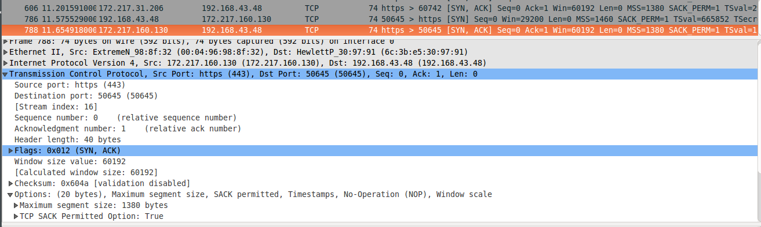

**12. Look again at the FIN packet you found for questions 10a and 10b. What was its end byte number?**

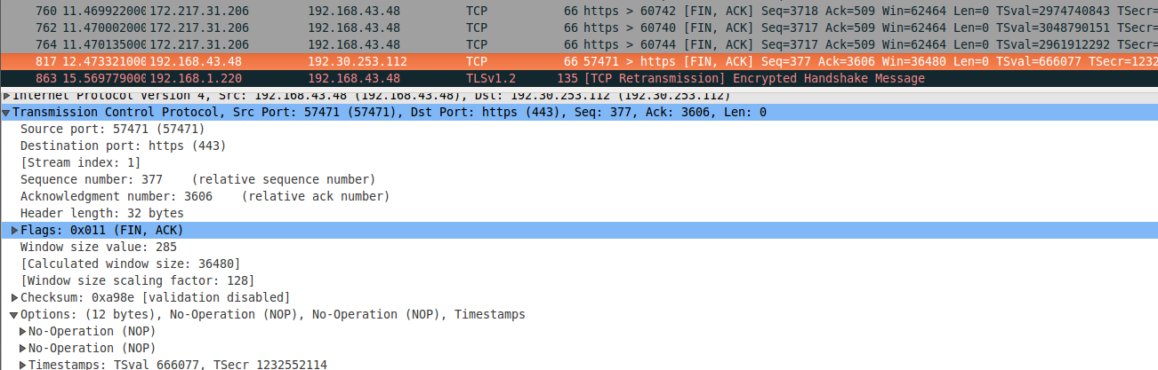

End byte number=Acknowledgement number=3606

**13. How many bytes were sent from the responder to the initiator of that TCP session?**



Bytes=32 bytes

**IPERF**

**Q1) Create an iperf TCP and UDP server, change the default bandwidth to 1000mb, change the interval between periodic bandwidth test 60 secs, 120 secs and 300 secs and find the speed of the network. Also find the maximum throughput achieved during UDP connection.**

**TCP connection.**

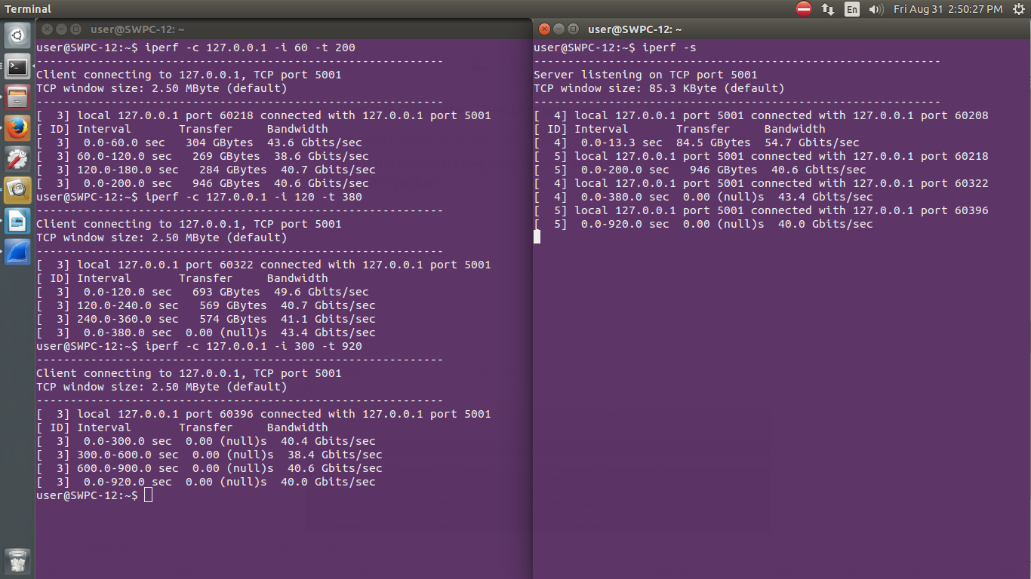

**UDP connection.**

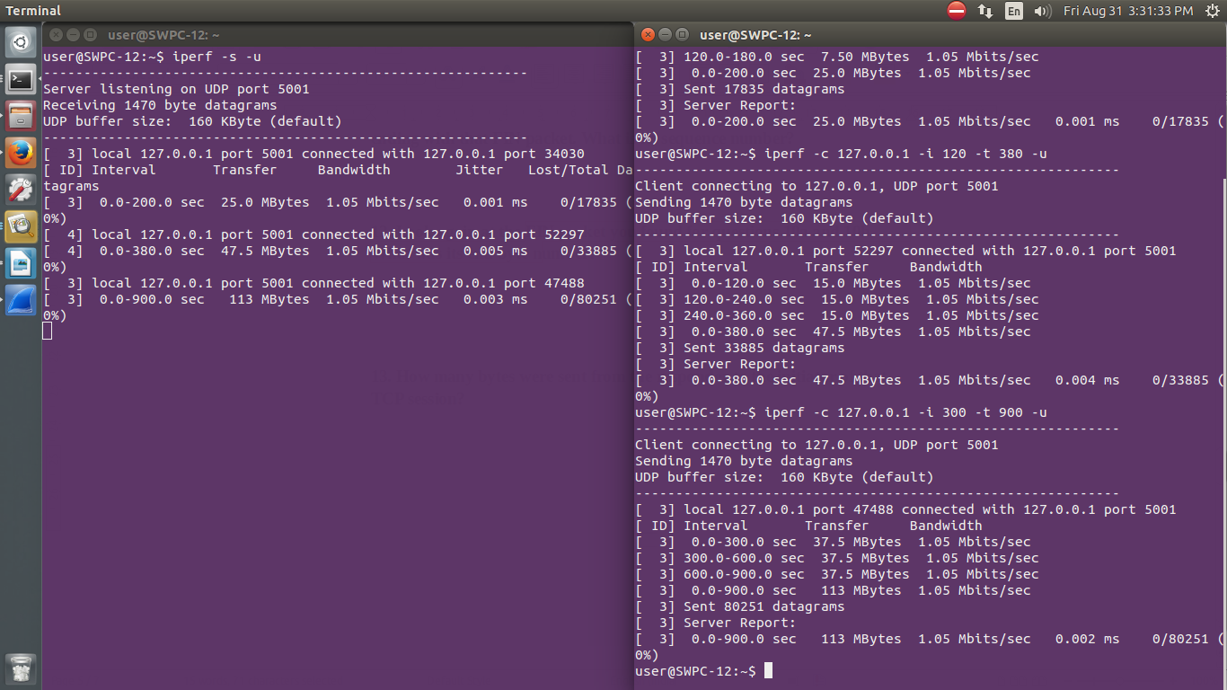

**Throughput**

